HERITAGE SINGERS CANADA
Grace Lyons, Founder & Musical Director
presents
REFLECTIONS
…A WALK DOWN MEMORY LANE

Come experience the music, the stories, and the dance of Olde-Tyme Jamaica and the Caribbean in an incredible setting. This is a journey that reveals the richness and creativity of Jamaican/Caribbean musical theatre and will include a tribute to the Hon. Louise Bennett Coverley (Miss Lou)…Jamaica’s cultural icon. The Heritage Singers will be joined by notable Jamaican performer Joan Andrea Hutchinson.
You’ll laugh, you’ll sing and you’ll ‘remember when’.

What better way to celebrate the 55th anniversary of Jamaica and Trinidad and Tobago than attending the 40th anniversary musical by the Heritage Singers?
Fun for all generations.

Act now!
Order your tickets from Ticketmaster
or the theatre box office.

Saturday
October 21, 2017

Matinee – 2:00 pm
$80 & $40

Evening – 7:30 pm
$100 & $50

Includes a tribute to the Hon. Louise Bennett Coverley (Miss Lou)

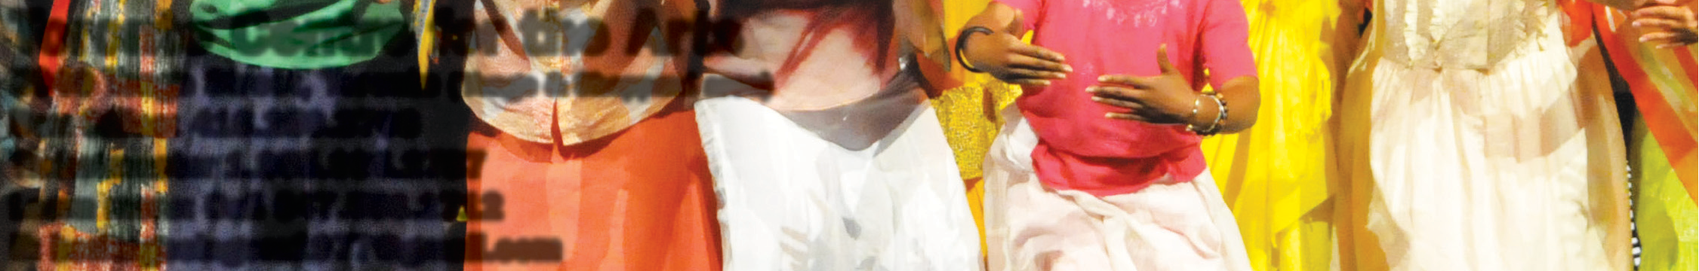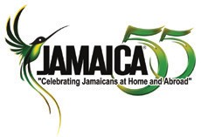

Toronto Centre for the Arts
5040 Yonge Street, Toronto (Yonge & Sheppard area)
Box Office: 416.250.3708
Ticketmaster 1.855.985.2787
Learn more: Call 647.556.2712
E: heritagesingers1977@gmail.com

